World 1

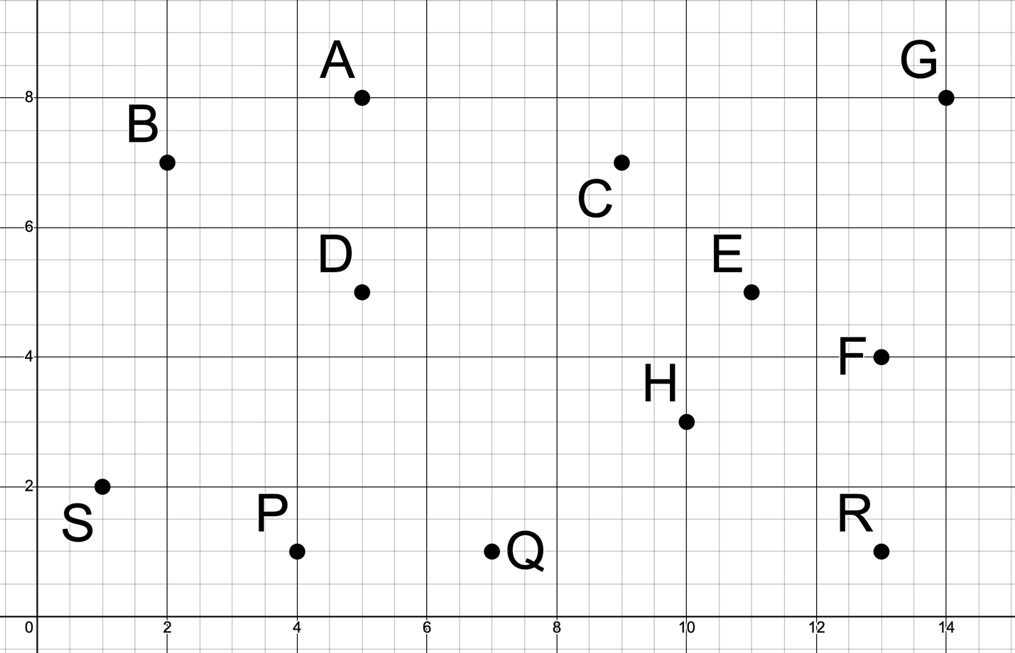
Successor Dictionary:
A: none
B: (A, 5)
C: (A, 6), (F, 8)
D: (B, 6), (C, 7), (E, 7)
E: (H, 4), (R, 7)
F: (G, 6)
G: none
H: (P, 9), (Q, 6)
P: (Q, 4)
Q: none
R: (F, 4)
S: (D, 8), (E, 14), (P, 4)
World 2

Successor Dictionary:
A: (C, 6), (G, 5)
B: (E, 6), (H, 6), (K, 5)
C: (E, 6), (H, 6)
D: none
E: (C, 6)
F: (J, 7), (K, 6)
G: (D, 6), (F, 5)
H: (E, 5)
J: (G, 5)
K: (B, 5), (E, 6), (J, 5)
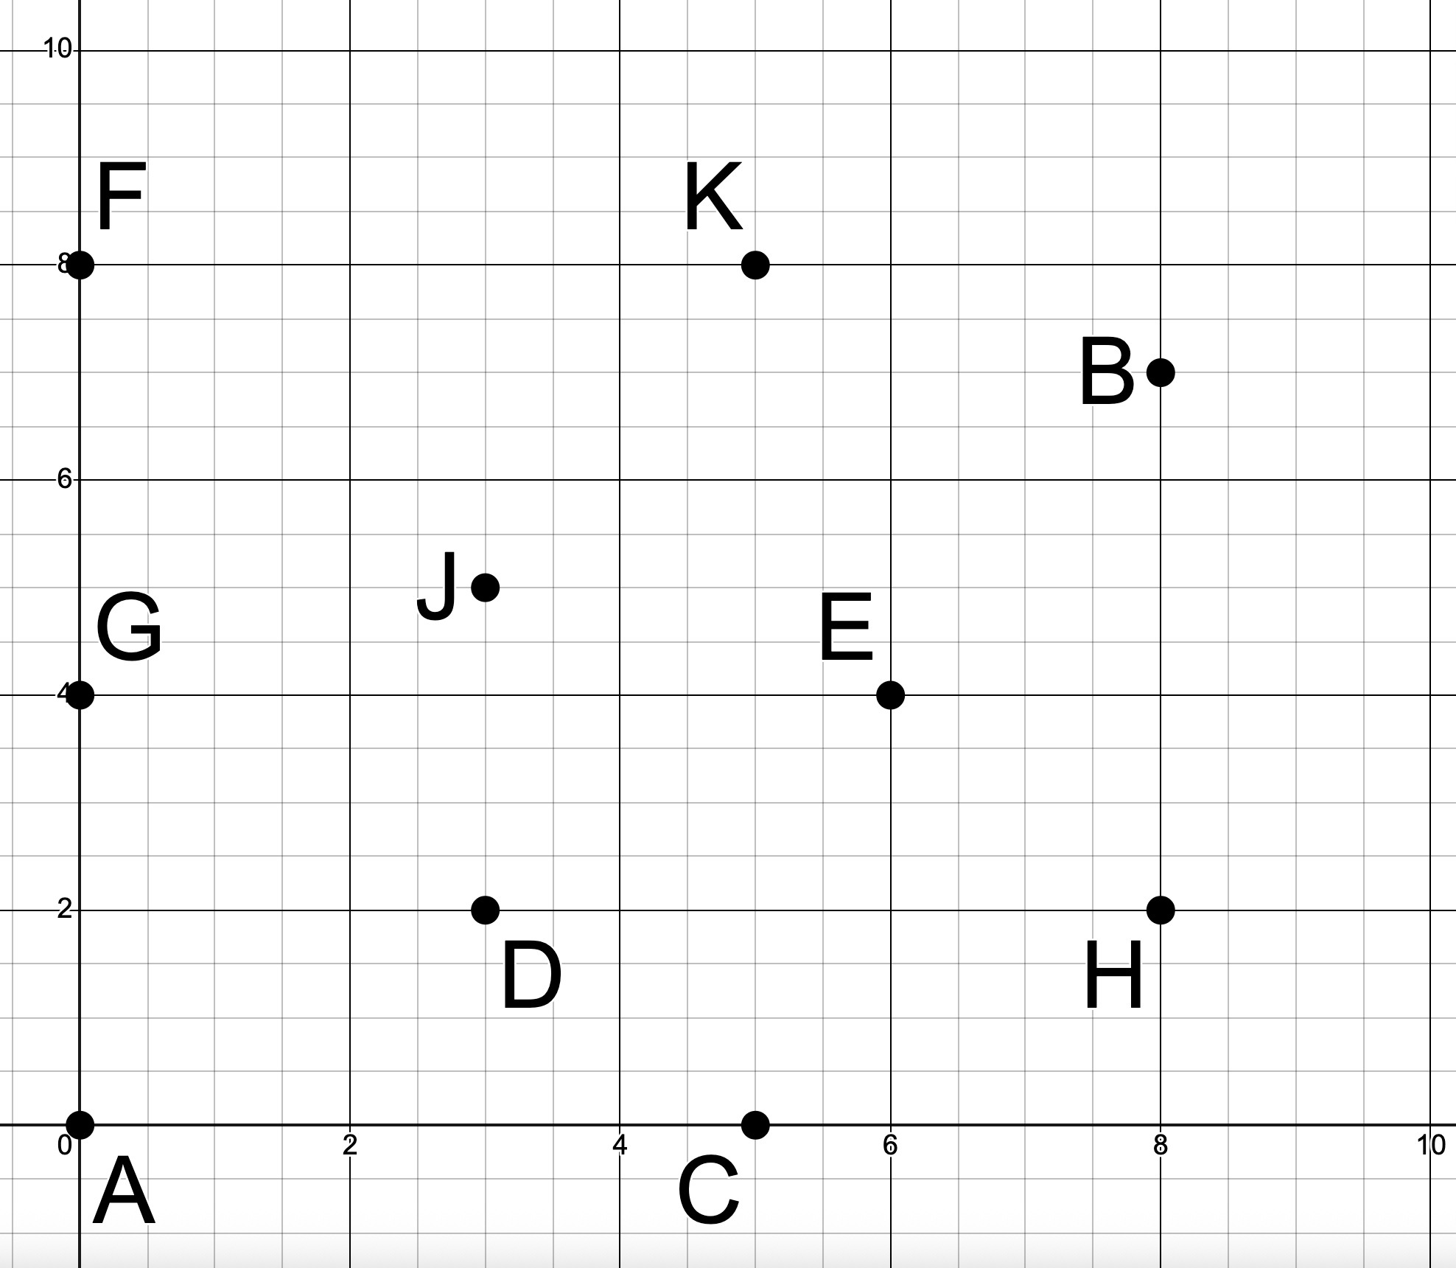

World 3

Successor Dictionary:
1: (go east to 6, cost = 5)
2: (go northwest to 6, cost = 6),
(go south to 8, cost = 8)
3: (go north to 4, cost = 5),
(go east to 7, cost = 4)
4: (go north to 1, cost = 4),
(go east to 2, cost = 6),
(go northeast to 6, cost = 9)
6: (go east to 9, cost = 5)
7: (go northeast to 2, cost = 6),
(go northwest to 4, cost = 9)
8: none
9: none
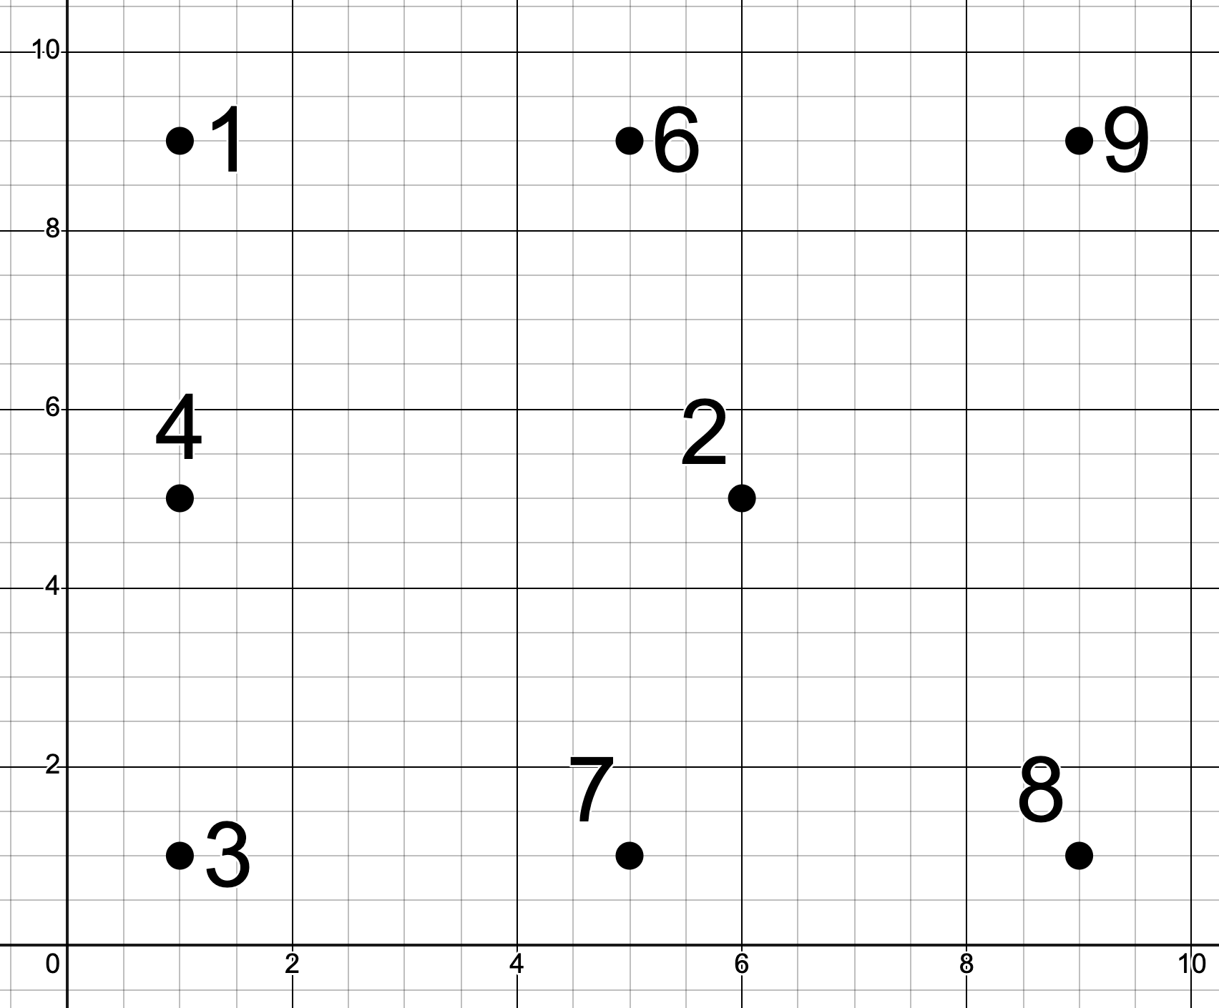
World 4

Successor Dictionary:
A: (B, 7), (C, 5)
B: (D, 5)
C: (E, 6), (D, 7)
D: (F, 3), (G,5), (H, 5)
E: (H, 7), (I, 7)
F: (I, 7)
G: none
H: none
I: none

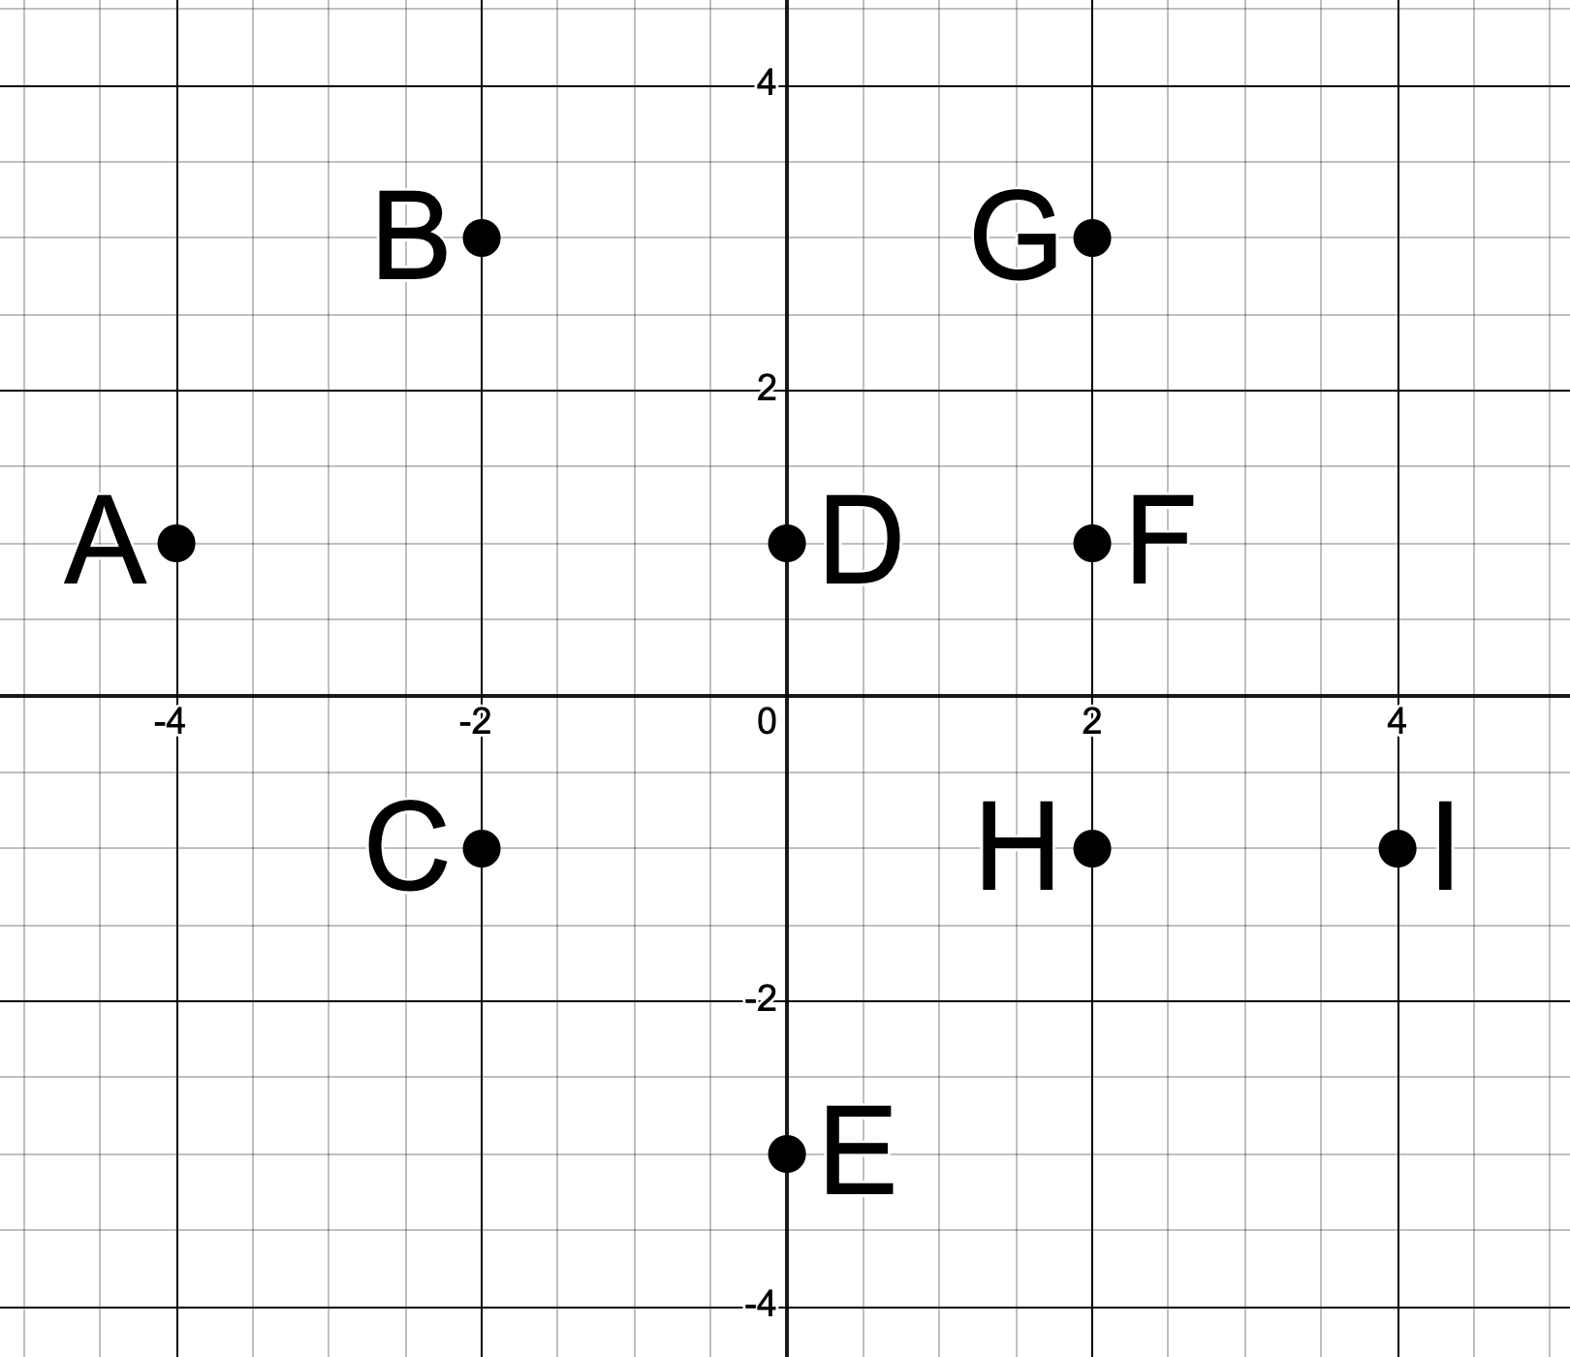

World 5

Successor Dictionary:
A: (go east to K, cost = 5)
B: (go east to G, cost = 5)
C: (go east to A, cost = 5),
(go west to J, cost = 9)
D: (go west to E, cost = 7),
(go east to H, cost = 5)
E: none
F: (go southwest to A, cost = 10),
(go west to G, cost = 6)
G: none
H: (go north to K, cost = 8)
J: (go north to B, cost = 5),
(go southeast to D, cost = 12),
(go south to E, cost = 7)
K: (go north to F, cost = 8)

